**AWS:**

**S3 server access logging**

Step 1 : go to aws management console and move to AWS s3 UI.

Step 2 : create 2 buckets ,such that one bucket for operations and second for storing the access files of bucket 1 into it.

Step 3: Now click on bucket1 and go to its properties.In properties ,go to “server access logging”.

Step 4: edit the server access logging and “enable it” and choose bucket 2 as “target bucket” for accessing the log files. And then click on “save changes”.

Step 5: Now upload some objects in bucket 1 ,to create some log files and perform other operations like open the files ,delete the file ,etc

Step 6: Now go to bucket2 and browse its objects .You will get the log files created for bucket 1 .So this is how we can access log files.

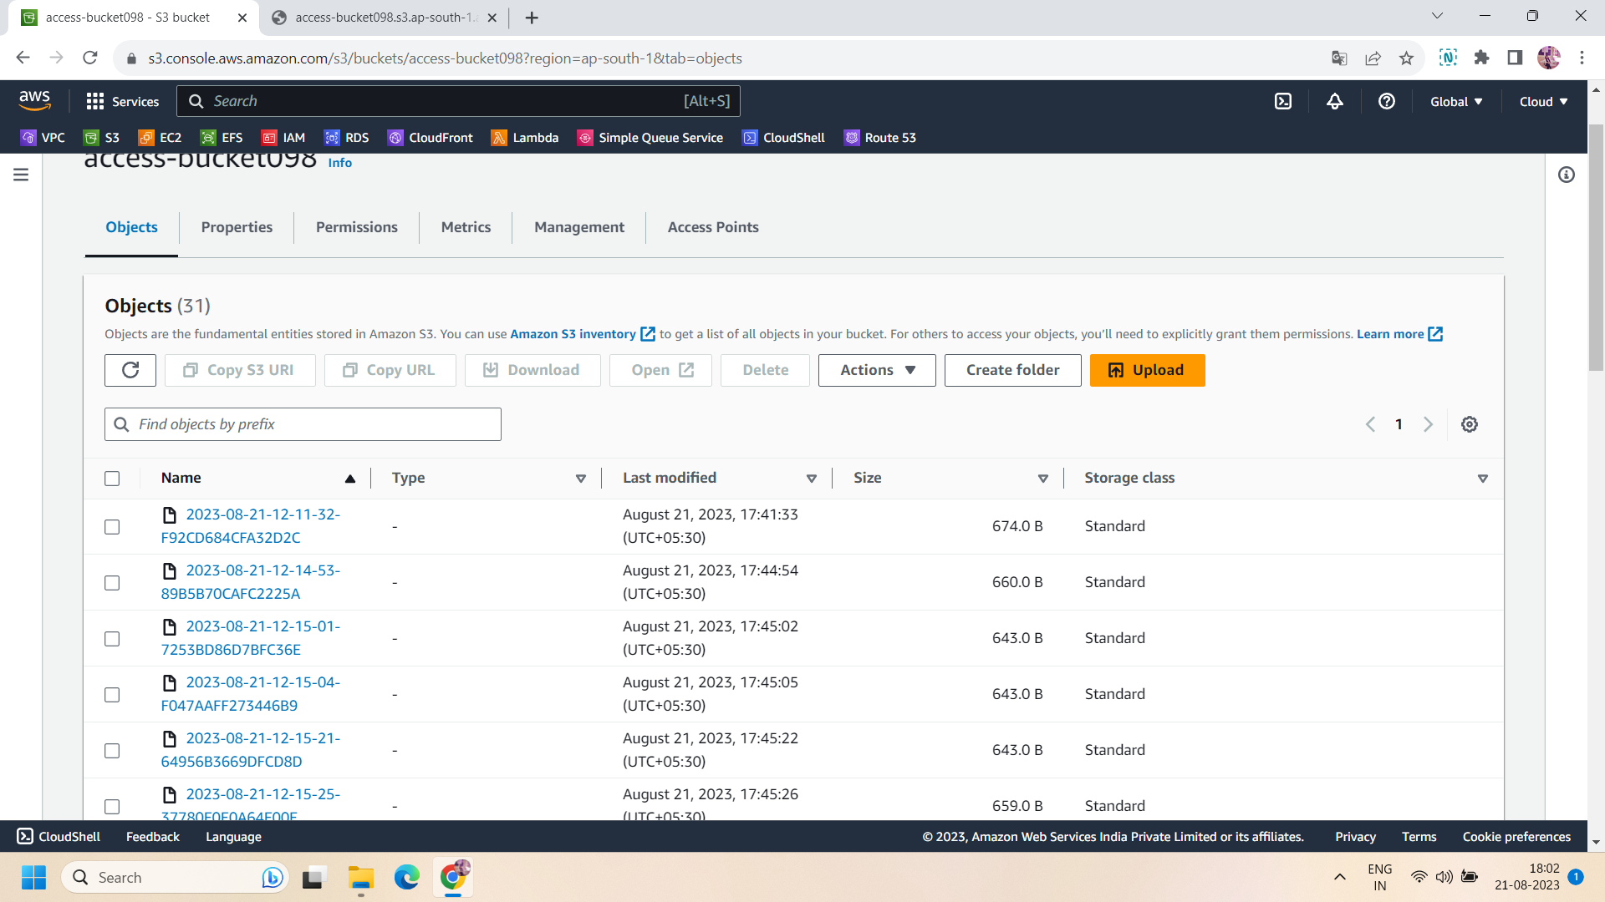

All done!!